**Experiment 2.1 Paul Thomas 30 S3 CSB**

**Program**

| class Employee{  int id;  String name;  String dob;  double phonnum;  String address;  double salary;    void printsalary(){  System.out.println(name+" "+salary);  }  }  class officer extends Employee{  String department;  String specialization;    void printall(){  System.out.println("\nID : "+id+"\nName : "+ name+"\nDOB : "+dob+"\nPhone Number : "+phonnum+"\nAddress : "+address+"\nSalary : "+salary+"\nSpecialization : "+specialization+"\nDepartment : "+department);  }    }  class manager extends Employee{  String department;  String specialization;    void printall(){  System.out.println("\nID : "+id+"\nName : "+ name+"\nDOB : "+dob+"\nPhone Number : "+phonnum+"\nAddress : "+address+"\nSalary : "+salary+"\nSpecialization : "+specialization+"\nDepartment : "+department);  }  } | class employee{  public static void main(String []args){  officer o = new officer();  o.id = 369;  o.name="Paul";  o.dob = "25.04.2002";  o.phonnum = 200;  o.salary = 43344;  o.address = "India";  o.specialization = "Machine Learning";  o.department = "Computer Science";  o.printsalary();  o.printall();  manager b = new manager();  o.id = 555;  o.name="Thomas";  o.dob = "26.05.2002";  o.phonnum = 300;  o.salary = 55344;  o.address = "Australia";  o.specialization = "Block Chain";  o.department = "Computer Science";  o.printsalary();  o.printall();  }  } |
| --- | --- |

Program

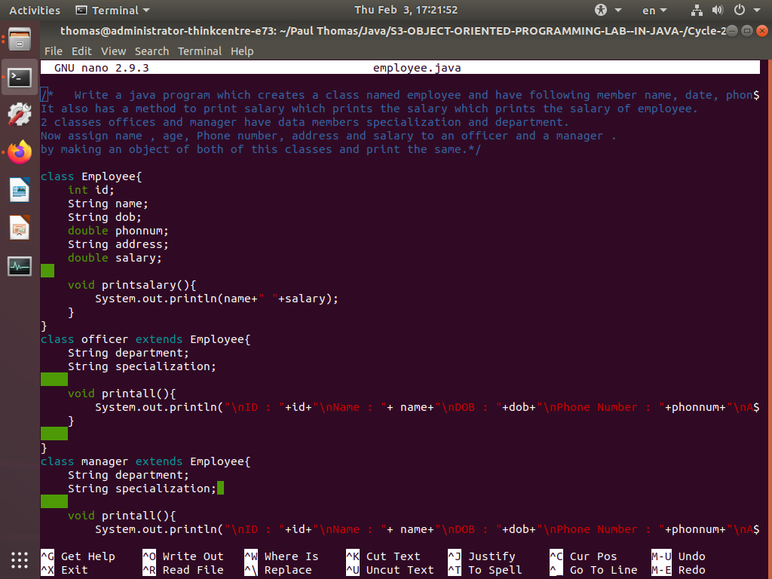

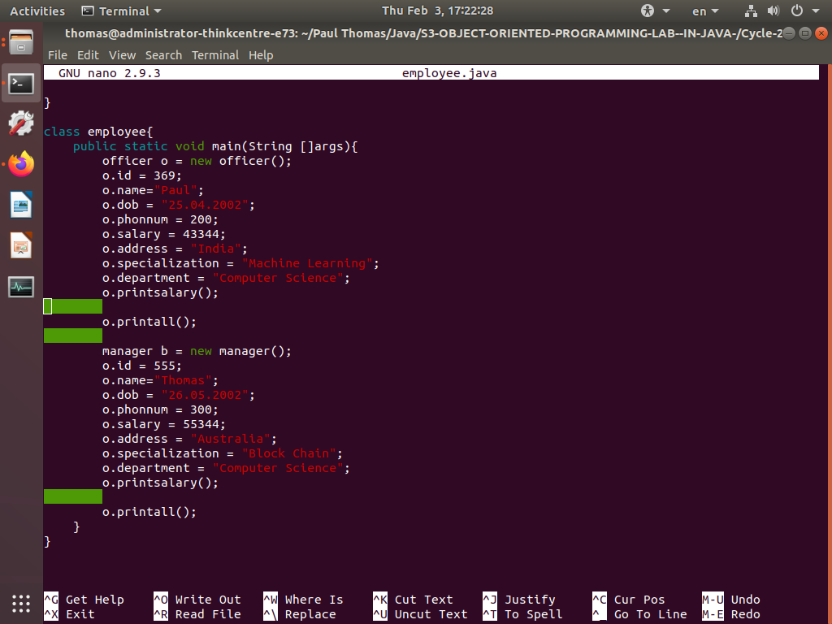

Output

